
PROJECT: CUSTOMER CHURN PREDICTION
Stage 2 Deliverable Scaling Technique Documentation

Student Name |  | Role
Poorni Dasanayake |  | Project Manager
Milan |  | Data Analyst – Predictive Modelling
Virajkumar Shihora |  | Data Analyst – Clustering Analysis
Tanjila |  | Business Analyst
Nishil |  | Data Engineer – Preprocessing & Feature Engineering

Scaling technique documentation

Introduction
The preprocessing of data includes feature scaling, and this is an important step when the machine learning algorithms are used, based on distances such as the K-Means clustering algorithm. This project has made use of scaling to ensure that all the numerical features contribute equally to the analysis. The features that have larger values will overpower the other features in the model unless downsized, and clustering will give biased and meaningless results.

Applied Scaling Method
The scaling technique that was used in the present project is StandardScaler, which scales the number features of an input dataset by transforming the number into a mean of 0 and a standard deviation of 1. This is to ensure that all features are taken to a similar scale and the overall distribution of the data remains intact.

Project Implementation
StandardScaler was also used to preprocess the numerical columns. This ensures consistency and reproducibility as they are trained on the same transformation as well as during clustering. The pipeline scaling facilitates the organisation of the preprocessing process, which is coherent with the best practices of machine learning processes.
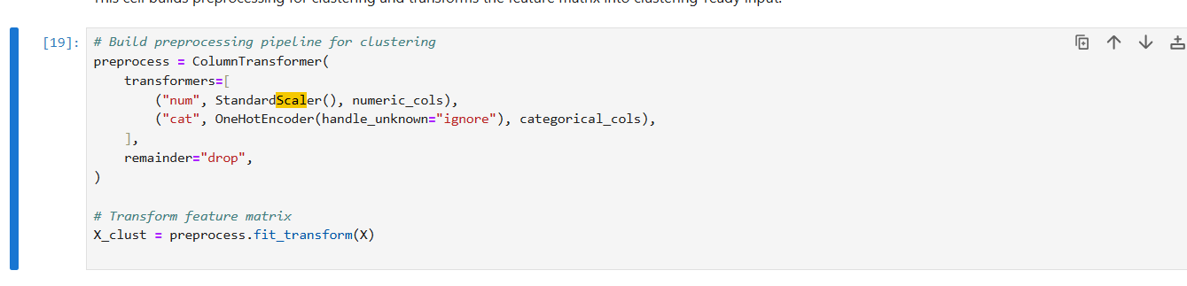
Figure 1: Code for the scaling

Rationale for Choosing StandardScaler
The selection of StandardScaler is particularly suitable for the K-Means clustering because the algorithm uses distance-based computations. Scaling of the variables with larger ranges will have an imbalanced impact on the clustering outcome if the features are not scaled. The solution to this is standardisation because all the features are able to contribute equally.
In comparison to the standardisation techniques such as Min-Max scaling, standardisation is more applicable in cases where the data set contains a varied distribution or intermediate outliers. It preserves the shape of data distribution but transforms the scale, and hence, is a good alternative to cluster tasks (Shaibu, 2024).

Impact on Model Performance
The use of StandardScaler helped to increase the quality of the clustering since it enabled equal contribution of all the entire numerical features. It contributed to the increased partition of clusters and parts that could be interpreted. Scaling also helped the K-Means algorithm to converge earlier leading to stable and consistent on results of clustering.

References
Shaibu, S. (2024). Normalisation vs. Standardisation: How to Know the Difference. [online] Datacamp.com. Available at: https://www.datacamp.com/tutorial/normalization-vs-standardization.
Vinod (2024). 07] Standardization and Normalization Techniques in Machine Learning: StandardScaler(), MinMaxScaler(), Normalizer()&RobustScaler(). [online] Medium. Available at: http://medium.com/@vinodkumargr/07-standardization-and-normalization-techniques-in-machine-learning-standardscaler-3890a89bddbf.

